1. select distinct d.customer_name

from Depositer_159 d, BankAccount_159 ba, Branch_159 b

where d.accno=ba.accno and ba.branch_name=b.branch_name

and b.branch_city="Delhi"

group by d.customer_name having count(b.branch_name)>1;

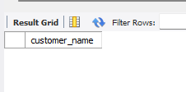

1. select l.branch_name

from Loan_159 l

where l.loan_no not in(select d.accno from Depositer_159 d

where l.loan_no=d.accno);

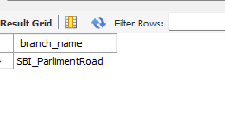

1. select branch_name from Branch_159

where assents_inlakhs > all

(select assents_inlakhs from branch_159 where branch_city="Bangalore")

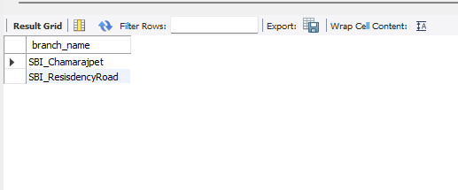

1. select l.branch_name

from Loan_159 l

where l.loan_no not in(select d.accno from Depositer_159 d

where l.loan_no=d.accno);

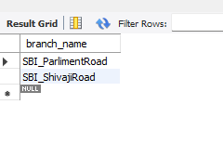

1. delete from BankAccount_159 ba

where ba.branch_name=(select b.branch_name from Branch_159 b where

b.branch_city="Mumbai");

select * from BankAccount_159;

1. update BankAccount_159

set balance=balance+((5*balance)/100) where accno in(1,2,3,5,8,9,10,11,12);

select * from BankAccount_159;

